[TopCoder Direct]
Conceptualization Phase

Conceptualization Document

Template v 1.1

10/25/2014

Project Mom and Pop – Platform for Small Businesses

Table of Contents

1.0 Introduction 3
1.1 Overview of Application 3
1.2 Project Objectives 5
1.3 Assumptions 5
1.4 Limitations 6
1.5 Open Items and Risks 7
2.0 Existing Business Flow 9
3.0 Proposed Workflow 10
3.1 Overview 10
3.1.1 New System Approach 10
3.2 Context Diagram 16
3.2.1 Web Application Context Diagram: 16
3.2.2 Dependencies 16
3.3 High Level Workflow 18
3.3.1 Web Application (desktop layout) 19
3.3.2 Mobile layout 28
3.4 Use Case Diagrams 36
4.0 Business Requirements 39
4.1 Inputs/Outputs 39
4.1.1 Inputs 39
4.1.2 Outputs 40
4.2 Task Requirements 41
4.2.1 Generic User Functionality (Desktop web layout) 41
4.2.2 Individual User Functionality (Desktop web layout) 44
4.2.3 Business Administrator Functionality (Desktop web layout) 47
4.2.4 Client Functionality (Desktop web layout) 50
4.2.5 Platform Employee Functionality (Desktop web layout) 51
4.2.6 System Functionality (Desktop web layout) 51
4.2.7 Generic User Functionality (Mobile layout) 53
4.2.8 Individual User Functionality (Mobile layout) 54
4.2.9 Business Employee Functionality (Mobile layout) 58
4.2.10 Business Administrator Functionality (Mobile layout) 58
4.2.11 Platform Employee Functionality (Mobile layout) 59
4.2.12 System Functionality (Mobile layout) 59
4.3 Security Requirements 60
4.4 Performance Requirements 62
4.5 Data Migration 62

Introduction

Overview of Application

The client for this project has decided to build a platform that will support the sale, exchange, and redemption of gift cards between businesses and individuals. The goal of this platform is to help small businesses expand, using both web and mobile layouts, by giving them a simple way to raise capital and acquire new customers using gift cards.

The client needs to create a high quality platform that is easy-to-use even for business owners that don’t have a lot of technical expertise. Many business owners are not technologically sophisticated, so creating a platform that is simple to understand and navigate is also a top priority.

The main function of the platform will be to allow business to post virtual gift cards for sale on the platform. Individual users will be able to browse and buy these gift cards, as well as resell or trade gift cards they own. Using the mobile layout, users will be able to redeem their gift cards at the business, and the business will be able to process gift card redemption at their point of sale.

The platform will include a web application with desktop, tablet and mobile layouts. Functionality in desktop and tablet layout will be the same, functionality of the mobile layer will differ. Some overlap in functionality will exist between the desktop/tablet and mobile layouts, and some functionality will be unique to one or the other (see section 3.1.2 and 4.2 for full details):

Overlapping functions
- Registration
- Searching gift cards
- Purchasing, reselling and trading gift cards
- Reporting

Unique Web application functions
- A gift card posting transaction

Unique mobile layout functions
- Point of sale transaction – Business perspective
- Point of sale transaction – Individual perspective

All of the platform users must have complete confidence in the safety and security of the processing system and the information contained within.

This conceptualization document will capture the business processes and requirements necessary for creating the new platform to accomplish these goals.

Application Problems

Currently, there is no platform available that focuses on the innovative use of gift cards as a way for businesses to raise capital and acquire new customers.

There is currently no gift card exchange platform on the market with an easy-to-use interface that is simple for non-technical small business owners to use.

Managing gift card transactions can be a complicated process and no platform currently exists to make managing these transactions simple.

Application Opportunity

There is the opportunity to give Client users quick access to a powerful platform through a set of tools, which can be used in an intuitive way thus making it easy to work with.

There is the opportunity to provide reports to assist the decision making process and simplify some of the tasks Client users must perform.

There is the opportunity to design a platform with an easy to use interface to attract novice or nascent businesses which would otherwise never have tried the platform.

There is the opportunity to build a platform to increase the efficiency of managing gift card transactions and sales for businesses.

There is the opportunity to architect the application using new technologies and best practices to allow for future enhancements to be made more efficiently and to minimize future development costs.

Return on Investment (ROI)

The official return on investment (ROI) for this project is confidential, but it would be possible for ROI to be determined by:
- Increased productivity: Reduction in time required by users to manage gift card transactions.
- Number of Client Users: The number of clients that sign up to use the platform, and the value of gift cards they sell, can be used as a factor to determine ROI.
- Number of Individual Users: The number of individual users that sign up to use the platform, and the value of gift cards they buy, resell, trade or redeem, can be used as a factor to determine ROI.

Definition of Terms and Acronyms

Admin | Administrator
Business | A business of any size or scale, platform clients
Client | The person associated with the business. A Client may be associated with more than one business.
Closed-loop | A term used for gift cards that means the gift card may only be used for one business or a group of businesses owned by the same owner.
Gift Card | An electronic gift card (mobile or virtual) used for the up-front purchase of goods and services from a business.
GUI | Graphical User Interface
Individual | The person who buys a gift card.
PC | Personal Computer
Point of Sale (POS) | The point of time when the gift card is redeemed in store.
RTF | Rich Text Format
TC | TopCoder
UI | User Interface
QR code | Quick Response Code - a type of matrix barcode

Project Objectives
The business objectives of this project are listed below. Delivering these objectives will deliver the expected benefits of the application.

Must Have:
- To build a new platform that supports all aspects of the sale of a closed-loop gift card from a small business to an individual, the resale from an individual to an individual, and trades between individuals.
- To build an application that allows businesses to sign up to offer gift cards for sale.
- To build an application that allows individuals to buy, resell, trade and redeem gift cards.
- To build an application that includes a marketplace for all currently offered gift cards for sale, resale and trade.
- To build a system that allows for the redemption of gift cards at the business.
- To design a system that is simple to understand and navigate for business owners that may not be technologically sophisticated.
- To build a system that includes reporting to help analyze data around gift card sales / redemption.
- To build a system that can interact with payment gateways.
- To build a secure system where users can be confident of the safety and security of the processing system and the information contained within.
- To design a new application using new technologies and best practices to allow for future enhancements more efficiently.
- To build an application that is scalable to handle a heavy amount of user activity even as the platform grows.
- To secure access to the application through the use of a security system.
- To design a system that supports user accounts with different roles / permissions (NOTE: users can have multiple roles in the system).

Nice To Have:
- Push notifications: if an individual goes to a business location where gift cards are currently available for purchase or trade, the mobile layout should prompt the individual.

Assumptions
Some assumptions generally must be made in order to write a succinct definition of the application. The assumptions are usually but not limited to the context in which the application will work.

Assumptions critical to the success of this project are listed below. A critical assumption is one without which the project will not succeed.

- The new platform will include will be a web application working in both desktop and mobile browsers.
- Users of the new application will be using a PC or mobile device (smart phone / tablet) with a web browser, a keyboard and a mouse (or equivalent).
- Users of the system will have Internet access (either from their PC or mobile device).
- There is no existing security system to leverage.
- Users will access the web application through a web-browser (either mobile phone or tablet or desktop/laptop).
- Users will use the app in the mobile browser at the point of sale.
- Users can have multiple roles in the system.
- Users can access the application from multiple time zones, but that must not affect anything in the application. The application must be time zone agnostic.
- The Client and Business Administrator can be the same person, but they don't have to be. For example, client may be a business owner or executive and business administrator may be an employee put in charge of managing the account.
- A business administrator should be able to cancel a gift card posting at any time; however, they must honor any outstanding gift cards.
- Forums should be viewable by the public, but one cannot post or comment unless registered. Registered users include businesses (verified and not verified) and individuals.
- The Business Administrator should have access to all Business Employee functions in the app.

Technical Assumptions:
- The platform should maximize the use of open source technologies and community-based services.
- The preferred language is JavaScript and frameworks based on it (node.js, angular.js).
- The new application should be designed to be scalable. In other words, as the volume of orders grows the system can scale by adding additional app servers, web services, database, etc. to make the application run correctly.
- For content management, the client has decided to use a CMS. The Architect is to decide which CMS meets both business and technical requirements the best.
- The web application must have a responsive layout for different screen resolutions (desktop/tablet and mobile). The UI designers must provide their solutions respectively. Different layouts may include different functionality (e.g. desktop layout doesn’t need to have functionality for gift card redemption which will be done with mobile devices only).

Limitations
Every project has limitations on the scope of the problem it attempts to solve, on the capabilities of the implementation technology, etc. The limitations of this project are listed below:

- The platform will be limited to virtual/mobile gift cards. It will not support physical gift cards.
- Sales of the business’ actual products will be external to this application (i.e. it will not be carried out with this application).
- At this time, gift card redemption will not include online purchases.
- The new system will not need to work directly with any peripheral devices (such as a barcode scanner, etc.). The mobile device should be able to meet all the scanning needs of the system by scanning QR codes.
- The platform will only be available in English at first. The application is for initially for USA users.
- The application will not include live chat – that is out of scope.
- The application does not need any internal printing functionality built into it.
- Payments in the system will be handled by an external payment gateway. Building a payment system is out of scope (the amount of the payment transaction should be saved within the system for reporting purposes, but the actual payment will remain external).
- The functionality for referring friends only needs to be basic – it doesn’t need to track invitees or have any bonuses for the user that makes the referral (unless the client decides otherwise in the future).
- Not all of the public pages from the website will be required for the mobile layout (open item dependent on user experience).

Open Items and Risks
During the conceptualization of the project and in the process of writing this document, some issues may have been discovered, and others may remain open.

Open Items and Risks for the Next Phases of the Application

- The look and feel of the application is not yet defined. TopCoder Studio contests may be run to define the look and feel. The UI should be simple to understand and navigate for business owners that may not be technologically sophisticated.
- The exact version of each technology to use for developing this application has not yet been defined. The preferred language is JavaScript, and the client has their suggestions. The specific technologies this new application will be built on will be defined by the architect.
- There are currently no requirements defined about the operating system or browser, which will be used. This open item should be defined during the architecture phase.
- How the data is stored in the new system needs to be decided by the architect. The general term “application database” is used in this document to describe where the data will be saved, but the technical details of this needs to be defined by the architect in the next stages of this project (decision is open for the architect and client to determine).
- The specific security system that authenticates / manages user accounts is still open for discussion. There is no existing security system to leverage. Choosing a LDAP server or any other solution is an open issue for the architect.
- The exact algorithm used by the system to calculate reliability ratings for users has not yet been defined. The algorithm and factors used in this calculation need to be defined in a future release of the application when it is added.
- The specific payment gateway (external) the platform will use has not been defined yet.
- There is currently no expected number of unique users and concurrent users. Not knowing this number is a risk since it makes it difficult to estimate the amount of user activity on the platform.
- The solutions to use for forum discussions have not been decided yet. The client is open to third party solutions..
- The full details around reporting (such as what information to include) have not yet been defined.
- The client is currently discussing how to handle external validation; it will be included in the posting requirements that have yet to be defined.
- Exactly which social networks will be utilized is not clear and is an open item. The client request Facebook and Twitter, but the inclusion of any additional social network integration is an open discussion.
- The following opportunities have been suggested and could be included in the application if the client wishes:
  - To save individuals payment method information.
  - To notify user about some of his/her gift card is expiring in advance.
  - Having all the user dialogue be inline, no popup windows - to meet the UX requirements (the final decision is up to Studio designers).

Open Items and Risks for the Next Versions of the Application
- To enhance the platform with new tools which support the client in the creation of the gift card based on internal Business data.
- In the future, Business Administrators and Business Employees may upload information from their current point of sale device (such as cash register, Square, etc.) to the platform.
- In the future, the help content in the mobile layout will be related to the current page.
- Sophisticated analytics will be developed in a later version of the platform.
- In the future, user reliability will be calculated by the platform (not using an external system). The client has decided to wait to implement reliability ratings for a future version of the platform.

Existing Business Flow

This project will be building an entirely new application so this section is not required (confirmed on forums).

Proposed Workflow

Overview
This section includes a concise description of the features and operation of the proposed solution. The context and workflow of the proposed solution are defined in subsequent sections.

For this project, the client would like to build a new platform that will support the sale, exchange, and redemption of gift cards between businesses and individuals.

Currently, there is no available platform that is easy for businesses to connect with individuals for the sale, exchange, and redemption of gift cards.
- In contrast, the new platform will support the sale, exchange, and redemption of gift cards between businesses and individuals.
- The new system will increase the efficiency of managing gift card transactions and sales for businesses.

Currently, there is no gift card exchange platform on the market with an easy-to-use interface that is simple for non-technical small business owners to use.
- In contrast, the new platform will have an easy to use interface to attract novice or nascent businesses which would otherwise never have tried the platform.
- The new system will be simple to understand and navigate for business owners that may not be technologically sophisticated.

New System Approach

For this project, the client would like to create a new platform that will support the sale, exchange, and redemption of gift cards between businesses and individuals.

The platform will appear as a web application available in both desktop and mobile browsers. It will have 2 functionality sets: one for desktop and tablet layout, another one – for mobile layout.

Please see section 1 for an overview of the different types of user roles and the overlapping functionality between the desktop/tablet layout and mobile layout. Full details about all of these things are explained below (organized by web/desktop/tablet and mobile layout).

Web Layout Overview

All application users will have to log in to the application to access purchasing, reselling, trading and reporting features, and use its tools. Except for viewing public pages all other activities require the user to log in.

The web platform should contain the following basic public pages:
- Homepage
- For the Business
- For the Individual
- Business Network
- How it works
- Credits Page - all those who have contributed to the platform
- Blog
- Forums
- Frequently Asked Questions - should be organized according to percentage of members who asked the question
- About Us
- Legal
- Contact
- Sign in

The homepage of the platform should serve as the gift card “market” of the site and should display all open gift cards for sale, resale or trade. The list of Businesses with open gift cards on the homepage should be organized by location, goal amount offered, etc. and should also display recommendations to users based on account activity and the specific criteria the user has been interested in.

Users should be prompted to log in or register upon actions such as:
- trying to purchase, resell or trade a gift card
- clicking the sign in button
- looking up account information
- accessing reports
- posting and commenting on forums

If the user receives a prompt to log in or register based on the above actions, as soon as the user logs in, the user should be redirected to the appropriate page.

Users should have the option to sign in with existing accounts (Facebook, LinkedIn, Twitter, etc.) or create a platform account.

The user should also be able to sign in from any page on the site.

Individuals – If the sign in button is clicked, the individual will be redirected from the login page to the home application screen, which will display their private profile including gift cards owned or up for resale or trade, amount sold, traded or redeemed with the information broken out by Business. An individual should also be able to view their profile from the homepage. This information should be private.

If the individual does not currently own any gift cards, a prompt will appear to browse the open gift cards.

For the owned gift cards, an individual can click a button to signal whether gift cards are for resale/trade. When the button is clicked, a form is activated to allow the individual to determine resale/trade price. This form will also display “share” buttons to offer gift cards for resale to friends of the individual on popular social networks (i.e. Facebook, Twitter, etc.)

The individual’s platform profile should show all Businesses currently supported by the individual and any gift cards currently available for resale or trade. This information should be private.

The individual should also be able to communicate with a Business via a chat box on the Business gift card page. This requires login.

A history of interactions with other users should appear on the Business pages and individual profile pages.

In future releases of the platform, users will be given a reliability rating based on payment history, account activity, etc. (NOTE: this reliability rating is out of scope for this version of the application).

Clients, upon log in, will be redirected to their profile page, where they can see a full report on the total amount of gift cards they have in circulation for each of their Businesses, including: total gift cards offered, amount sold, amount remaining and amount redeemed. If a gift card is not currently in progress, time until the next gift card post can be published will be displayed. There will also be a place for clients to assign Business administrators and permissions.

There will be one form for registration, where the user first self-selects as a gift card user OR business owner. Then the user may create an account with a name, email address & password OR login with social media.
If the user choses to register as a business owner, they will be prompted to either request verification or continue browsing the site. Upon requesting verification, the user will be prompted to pay the monthly subscription fee. The verification request will not be processed until the subscription fee is paid. Until a business is verified, the status will say "Not a verified business". Once the business has been verified, the status will change to "Verified business”.
When the business signs up for a gift card offering, they will commit to paying the monthly fee until all gift cards have been redeemed.
- If a business does not pay the membership fee, it will lose access to all reports. Only the business loses reporting access - the gift card users, if there are any at that time, will still be able to see their balance and history. The gift card users will still be able to redeem their gift cards (as long as the business is open for business).
- If a business has an active gift card offering and payment is not received, the system will put the offering on hold and no new gift cards may be purchased until payment has been rendered.
- If a business does not have an active gift card offering and does not have any outstanding gift cards from a previous offering, they will just not be able to post a gift card offering until they pay the membership fee.

Business Administrators, upon log in, will be redirected to their profile page, where they can see a full report on the total amount of gift cards they have in circulation, including total gift cards offered, amount sold, amount remaining and amount redeemed. If a gift card is not currently in progress, time until the next gift card post can be published will be displayed.

A current gift card posting report should display goal amount, progress towards goal, amount needed to reach goal, and a list of individuals who have purchased gift cards. The Business administrator account should additionally be able to edit the Business profile, initiate a gift card post transaction and add a Business employee account.

A gift card may not be posted for sale until the following requirements are satisfied:
- The Business has no active gift cards
- The amount of the transaction is set
- The Business has been verified
- The Business has paid the monthly subscription fee
- The account for the Business to get paid through platform has been verified
- Any additional predetermined posting requirements are met

Once the transaction requirements are satisfied, the gift card can be officially posted and will be published on the platform.

Each gift card post should display the attributes of the gift card posting transaction, the attributes of the Business, the attributes of the gift cards that are to be issued and other legally required disclosures. There should be a place to list the current individuals (but how much the individual purchase will be private).

If the gift card post reaches the end date before the maximum threshold, the posting will be closed.

If a gift card post has reached the post end date, and it does not reach the amount of the transaction (maximum threshold), the client will accept the current amount of the transaction and the posting will be closed.

When a posting is closed or hits a milestone, the application should send an email notification to the Business Administrator and Client.

Platform Employees are users which may help a Business or individual with a transaction on the platform.

The Frequently Asked Questions page (FAQ) should display most popular questions in order from most to least, as well as the percentage of users who asked the question.

Mobile Layout Overview

The mobile layout will be created for mobile Chrome and mobile Safari browsers.

The mobile layout will have the following groups of functionality for different user types:
- Gift card Search and Purchase – all users should be able to view available gift cards as the feed is a public page.
- Gift card Reporting – for the Business Administrator
- Gift card Point of Sale – for the Business Administrator and Business employees
- Gift card Wallet – for the Individual (includes reporting and point of sale)

In order to use the mobile layout functionality, the user must sign in. Users should be able to view public pages on the mobile layout without registering or signing in.

Users should have the option to sign in with existing accounts (Facebook, LinkedIn, Twitter, etc.) or create a platform account.

The mobile layout should allow user to provide feedback from any page.

The mobile layout should allow a user to access “Help” from any page to learn more with pictures, diagrams and videos. Eventually, the help content will be related to the current page.

Gift card Search and purchase mobile layout functions

The functionality of this mobile layout will be similar to corresponding parts of the web application.
The individual should be able to browse all open gift cards and purchase them. For the owned gift cards, an individual can click a button to signal whether gift cards are for resale/trade. When the button is clicked, a form is activated to allow the individual to determine resale/trade price. This form will also display “share” buttons to offer gift cards for resale to friends of the individual on popular social networks (i.e. Facebook, Twitter, etc.)

Gift card Reporting – for the Business Administrator

Business Administrators, after logging into the gift card Reporting mobile layout and upon opening the application, the Business administrator should be brought to a reporting page similar to profile page in desktop layout. The page should display progress toward goal, time remaining until expiration, amount resold and amount redeemed.

Point of Sale – for the Business Administrator and Business Employees

Business Administrators and Business Employees, after logging into the Point of Sale mobile layout and upon opening the application, the Business should be prompted to initiate a Point of Sale by selecting the option to:
- Scan the QR code on the receipt/total, OR
- Upload a picture of the receipt/total, OR
- Manually enter the total, OR
- In the future, upload information from the current point of sale device (cash register, Square, etc.)

Through the mobile layout Business Admin/Employee then scans a QR code from Individual’s mobile device. It contains the gift card and Individual’s data.
The QR code is decoded and the total bill is then decremented from the individual's gift cards that relate to that business/location that are marked for use.

Gift Card Wallet – for the Individual

The Gift Card Wallet will include reporting and point of sale functionality.

Individuals, after logging into the Gift Card Wallet and upon opening the application, the Individual will be brought to their private profile summary page that summarizes the currently owned gift cards broken out by status (flag for resale, trade or use). The individual will have the option to view gift cards in other ways (e.g. by industry). The individual can click on any of the subcategories to drill down to Business specific level of detail. If we have permission to use the individual’s location, the list can be sorted by distance, with their current location at the top.

The top of the profile page should have a button for “Redeem Now”. Clicking the “Redeem Now” button generates a QR code and displays it on the individual’s mobile device. The QR code contains characters that make a key for the gift card and Individual. The Individual then uses his/her mobile device and shows the QR code to the Business to scan.

The mobile layout will prompt the individual if additional payment is required to complete the transaction. If not, the individual is prompted and brought to the current Business’s entry in the wallet with the current balance and the most recent transaction listed in the detail.

Context Diagram
The Context Diagram illustrates the modules, business processes, etc that feed or interact with this proposed application.

Web Application Context Diagram:
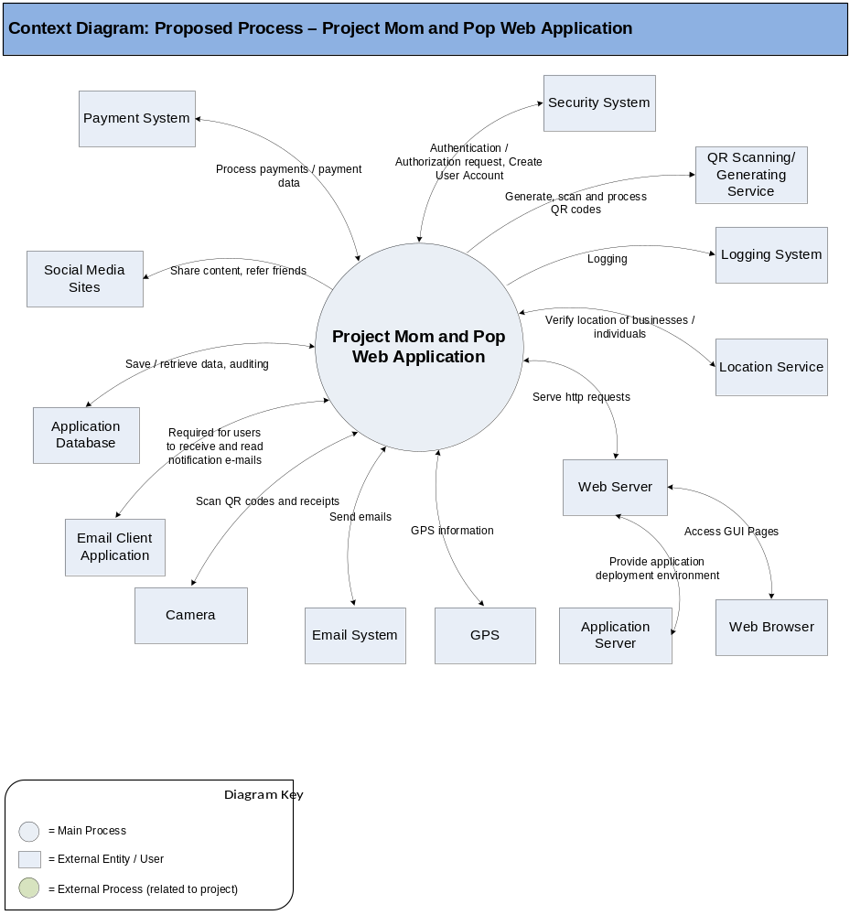

Dependencies
The list below enumerates external applications, business procedures, personnel, etc, that are required to achieve the objectives of the proposed application. Those systems would be listed here.

Payment System
The platform will use an external payment gateway to handle payments. The amount of the payment transaction should be saved within the system for reporting purposes, but the actual payment will remain external via the payment gateway.

Application Database
The system will save application data into an application database. This could also be used to store auditing data (open item: details on how auditing is done is up to the architect to design).

Security System
The application will use a security system to authenticate/authorize users before they can use certain functionality.

Location Service
The location of individuals may be verified by an external system. Please note, determining the location of businesses will be handled by the client for validation purposes.

Web Server
The application will be installed on a web server so users will be able to access it from anywhere.

Application Server
The application will be installed on an application server for deployment.

Camera
The mobile layout will depend on the camera to scan QR codes.

GPS
The mobile layout will depend on GPS for determining the user’s location.

QR code scanning/generating service
3rd party tool used to parse and generate QR codes.

Social Media Sites
The application will send out share requests and referral invites to friends via social media sites.

Web Browser
Users will access the application through a web browser.

Logging System
The application is dependent on the logging system.

Email System
The application will send email (such as notifications and feedback).

Email Client Application
Email client application is needed for the business and client to receive and read notification e-mails.

High Level Workflow
The workflow required to complete the primary objectives of the proposed application is described below. The workflow is business-centered, and includes “decision forks” for decisions the business user, or application, must make to achieve the objective. The workflow omits application faults or exceptions.

The workflows required to complete the primary objectives of the existing application are described below.

Web Application (desktop layout)

User Login / Registration Workflow (Desktop web layout)

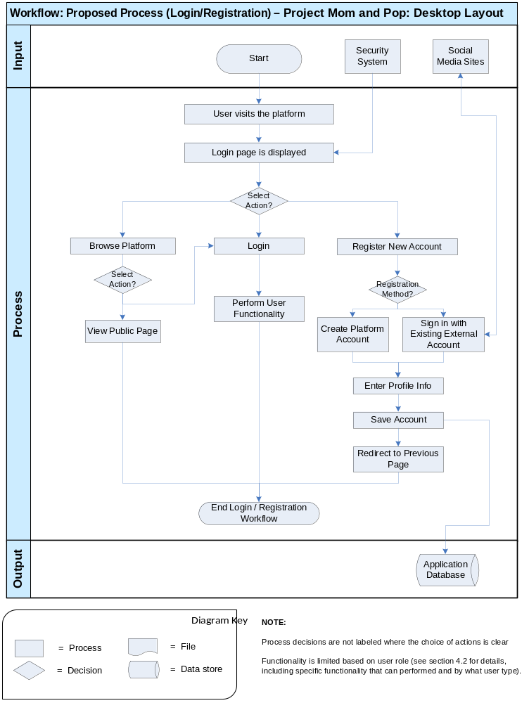

The workflow diagram above shows the login / registration process in the desktop layout of the new web application.

User Workflow – Registration
- Upon visiting the platform, the user will be brought to the login page where they will be prompted to either sign in or browse the platform. If the user chooses to browse they will be brought to the homepage displaying all open gift cards for sale, resale, or trade. The sign-in page should also display buttons at the top of the page allowing the user to navigate directly to any public page on the platform. When user signs in they must be able to choose “Remember me” option, so that the browser will keep them signed in during some configurable period (several weeks) or until user removes cookies.
- The user may browse every public page of the site but will be prompted to sign in upon attempting to make any buying, selling or trading action, and an attempt to view account details. The user is brought to the sign in page to proceed.
- If the user chooses to register, they will be prompted to choose to register as either a client or individual. A user will be prompted to register upon taking any of the following actions:
  - If the user is attempting to purchase or trade a gift card.
  - If the user is attempting to post a gift card.
  - If the user follows a link sent by an existing platform individual or client through the platform or from any non-platform source (social network, email, etc.)

Registration for the Client
  - The client will be prompted to sign in with an existing account (Facebook, LinkedIn, Twitter, etc.) OR enter an email address and password. They will have the option to create a business profile for the Business which will include the name of the business. The profile will include a description of the business to be seen on any of the posted gift cards.
    - Possible Bottleneck: The speed and performance of the social media platform of the user’s existing account is a possible bottleneck on the application.
  - The client should also be able to post an optional profile picture and/or logo.
  - Upon completion of the form, the client will be brought back to the page that initiated the call to registration.
  - Also they will be prompted to either request verification or continue browsing the site. Upon requesting verification, the user will be prompted to pay the monthly subscription fee. The verification request will not be processed until the subscription fee is paid. Until a business is verified, the status will say "Not a verified business". Once the business has been verified, the status will change to "Verified business”.

Registration for the Individual
  - The individual will be prompted to sign in with an existing account (Facebook, LinkedIn, Twitter, etc.) OR enter an email address, name and password.
    - Possible Bottleneck: The speed and performance of the social media platform of the user’s existing account is a possible bottleneck on the application.
  - There will be an option to upload a profile picture.
  - The individual will then be brought back to the page that originated the call to register.

Individual Workflow (Desktop web layout)

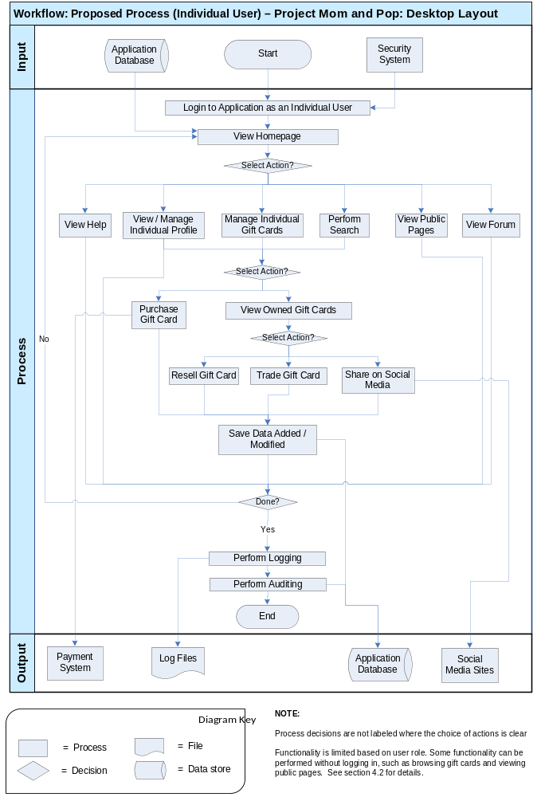

The workflow diagram above shows the high level process for Individual users in the new web application.

- The user logs into the system as an Individual user (authenticated by security system). See login / registration workflow above for details.
  - Possible Opportunity: There is the opportunity to leverage some external security service (the client does not have an existing security system).
  - Possible Problem: If there is a problem with Internet access or a connection to one of the external system dependencies (see 3.2.2) the user may not be able to access the application or have the application function correctly.
- The homepage will be displayed for the Individual user.
  - The content and functionality available on the homepage will vary based on user role.
- The user will be able to select different actions to perform:
  - View Help
  - View Individual Profile
    - This includes the ability to edit their Individual profile
  - Manage Gift Cards
    - Purchase a gift card
      - The individual may browse all open gift cards from the home page and click on a specific gift card posting, OR the individual may search for a specific gift card posting from the search box on any page, OR the individual may follow a link from an external source (social network, email, etc.) to directly link to a gift card posting.
      - From the gift card posting profile, the individual will click on the “Buy gift cards now” button.
      - A form will pop up that enables the individual to agree to the specific terms of the gift card as well as the denominations and the quantities of gift cards.
      - Once all the necessary data points are entered, the individual will be brought to a confirmation page that will bring the individual to different payment options (e.g. Amazon, PayPal, etc.)
        - Possible Bottleneck: The speed and performance of the payment processing service is a possible bottleneck on the application.
      - Once payment is confirmed, the gift cards will be issued and the transaction will be posted in the individual’s profile that may be accessed through the Web application or the gift card wallet mobile layout.
      - The individual will be brought to their private profile page so they can view the recently purchased gift cards.
    - View gift card the user owns
    - Resell a gift card
      - Upon logging in to the Web application, the individual will be able to view their private profile. The private profile will itemize owned gift cards by Business and each row should display a “resell” button.
      - Upon pressing the resell button the individual should be presented with a form to determine the desired resale price and easily select all the gift cards for that Business to be included for resale.
      - The form should communicate whether or not the gift card has exceeded the resale date/time. Although the individual can still resell the gift card, it is important for them to know if they will be competing with a Business’s current gift card posting.
      - If the Business has a gift card currently posted, the individual should be informed of the discount offered.
      - If another individual has gift cards for the same Business currently posted for resale, the individual should be informed of the discount offered.
      - The form will also display “share” buttons to offer gift cards for resale to friends of the individual on popular social networks (i.e. Facebook, Twitter, etc.)
      - Once the price has been confirmed, the user should be notified that their gift card has been offered for resale to all other platform members and the other broadcasted networks that they chose.
      - The gift card should then appear as “For Resale” in the open gift card postings.
    - Trade the gift card
      - Upon logging in to the Web application, the individual will be able to view their private profile. The private profile will itemize owned gift cards by Business and each row should display a “trade” button next to the “resell” button.
      - Upon pressing the trade button the individual should be presented with a prompt to easily select the number of gift cards for that Business to be included for trade.
      - Upon pressing the trade button the user should be notified that their gift card has been offered for trade to all other platform individuals, and the gift card should then appear as “For Trade” in the open gift card postings.
      - When a second individual comes across the posting for the “For Trade gift card” and clicks on it, the second individual should be presented with a form on which the second individual can choose which owned gift card they would like to trade with the first individual.
      - There may be rules around the value/denominations of gift card trading. If there are rules, the second individual should be informed if the trade meets those rules.
      - The original individual will then be notified that their gift card has been chosen for trade.
        - Possible Bottleneck: The speed and performance of email notification system is a possible bottleneck.
      - Upon viewing the notification, that user should be presented with a form on which they can confirm, negotiate or decline the trade.
      - If the trade is declined, the second individual will be notified and the transaction will cease. If the trade is negotiated, the two individuals may continue going back and forth until a trade is confirmed or declined. If the trade is confirmed, the both users will be notified and the transaction will be approved.
      - When the transaction is approved, the designated gift cards will be swapped into the other Individual’s profile.
    - Share a gift card sale or trade offer on popular social media sites.
      - Possible Opportunity: There is the opportunity to leverage an existing social media sharing system (many open source solutions exist). Alternatively, the system could leverage the APIs of the largest social media sites (such as Facebook and Twitter).
      - Possible Bottleneck: The speed and performance of the social media platform used for sharing is a possible bottleneck for the application.
    - The application will save updates to the system for any of these actions.
  - Search for gift cards
  - View public pages including forums (see section 4.2 for a full list)
    - Possible Problem: If there is a problem connecting to the CMS the user may not be able to access public pages.
  - View forum discussions
- The user can log out of the system when they are done.
- Logging will be performed.
- Auditing will be performed.
- The user will be logged out from the system in case of idleness during a configurable period.

NOTE: Some functionality in the above workflow can be performed without being logged in to the system – see “Generic User” functionality in section 4.2.

Business Administrator Workflow (Desktop web layout)
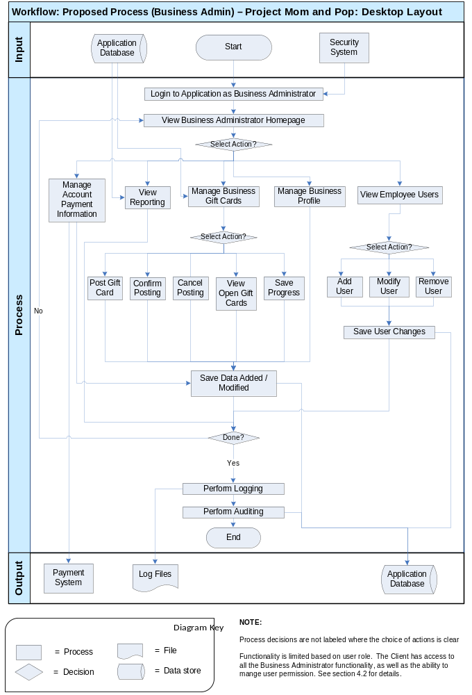

The workflow diagram above shows the high level workflow for Business Administrator users in the new web application.

- The user logs into the system as a Business Administrator user (authenticated by security system). See login / registration workflow above for details.
  - Possible Opportunity: There is the opportunity to leverage some external security service (the client does not have an existing security system).
  - Possible Problem: If there is a problem with Internet access or a connection to one of the external system dependencies (see 3.2.2) the user may not be able to access the application or have the application function correctly.
- The homepage will be displayed with content and functionality available for the Business Administrator.
- The Business Administrator will be able to select different actions to perform:
  - View Reporting
  - Manage Business Gift Cards (the gift cards issued by the business)
    - Post a new gift card
      - Upon clicking the “Post a gift card” feature at the top of the Webpage that displays all open gift cards, the client or the Business Administrator will be prompted to fill out a gift card Posting Application form.
      - The form should be saved as a work in progress.
      - The form will require the purpose for the posting, start date, end date, max threshold, currency and locations for redemption.
      - The application to post a gift card will have additional requirements to be determined.
      - Upon completion of the application, the client should be prompted to verify their account information.
      - Once completion of the form is confirmed and account information is verified, the Business will be notified via email.
      - Once the Business submits the confirmation link, the account will be charged and the gift card post will be published on the platform.
        - Possible Bottleneck: The speed and performance of the payment processing service is a possible bottleneck on the application.
      - The Business will be sent to the gift card posting profile page and encouraged to download the appropriate mobile layouts.
    - View their open gift cards
    - Cancel Posting – The Business Administrator can select to cancel an existing gift card posting. The gift card will no longer be available for purchase by individuals after the posting has been cancelled.
  - Manage Business Profile
    - The Business Administrator can edit their business profile.
    - It will include verifying the business account. Upon requesting verification, the user will be prompted to pay the monthly subscription fee. The verification request will not be processed until the subscription fee is paid. Until a business is verified, the status will say "Not a verified business". Once the business has been verified, the status will change to "Verified business”.
  - Manage Account Payment Information
  - View Employee Users
    - The Business Administrator can add, modify, or remove any of these users. The following steps are taken to add an employee:
      - From the Business profile page, the user should be able to click an “add new employee account” feature
      - The user should be prompted to enter an employee name and secret code that employee will use for authentication.
      - Employee will be externally instructed how to proceed.
      - Upon initial login to the “gift card Point of Sale” mobile layout with the secret code, the employee should be brought to a step-by-step tutorial for how to complete the point of sale.
- The application will save updates to the system for any of these actions.
- The user can log out of the system when they are done.
- Logging will be performed.
- Auditing will be performed.
- The user will be logged out from the system. They will not be able to access certain the application functionality until they open it again and go through the login process.

NOTE: The Client user also has access to all of the Business Administrator user workflow. In addition, the Client can set permissions for which employees have the role of Business Administrator (see section 4.2 for details).

Mobile layout

User Login / Registration Workflow (Mobile layout)

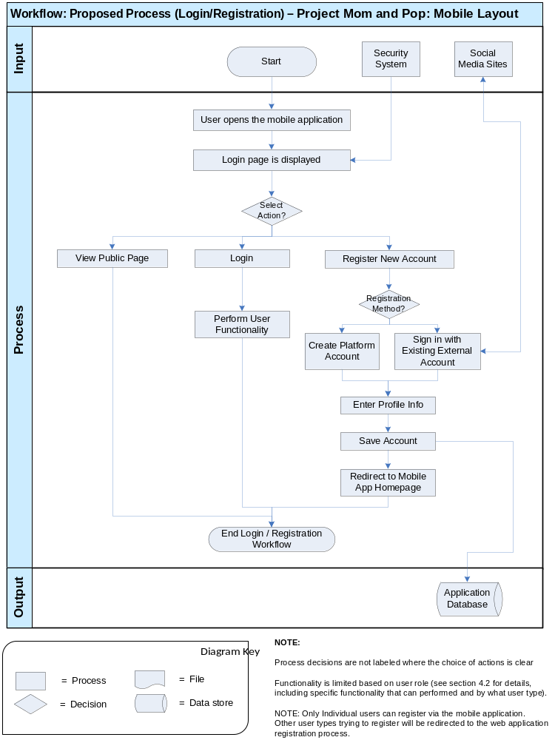

The workflow diagram above shows the login / registration process in the new mobile layout.

User Workflow – Mobile Registration
- The user will be prompted to sign in or register when a mobile layout is opened. They will also have the option to view public pages without logging in (the specific public pages are an open item). When user signs in they must be able to choose “Remember me” option, so that the browser will keep them signed in during some configurable period (several weeks) or until user removes cookies.
- If the user is attempting to open the “Gift Card Search and Purchase” or the “Gift Card Wallet” functionality in the mobile layout, the user will be prompted to register as an individual.
- If the user is attempting to open the “Gift Card Reporting” functionality in the mobile layout:
  - If the user is not already registered as a Client or Business Administrator, the user will be guided through next appropriate steps and redirected to the web application or a different mobile layout.
- If the user is attempting to open the “Gift Card Point of Sale” functionality in the mobile layout:
  - If the user is not already registered as a Client or Business Administrator or Business Employee, the user will be guided through next appropriate steps and redirected to the web application or a different mobile layout.

Mobile Registration for the Individual
  - The user will be prompted to sign in with an existing account (Facebook, LinkedIn, Twitter, etc.) OR enter an email address, name and password.
    - Possible Bottleneck: The speed and performance of the social media platform of the user’s existing account is a possible bottleneck on the application.
  - There will be an option to upload a profile picture.
  - The user will then be brought back to the main mobile layout home page.

Individual Workflow (Mobile layout)

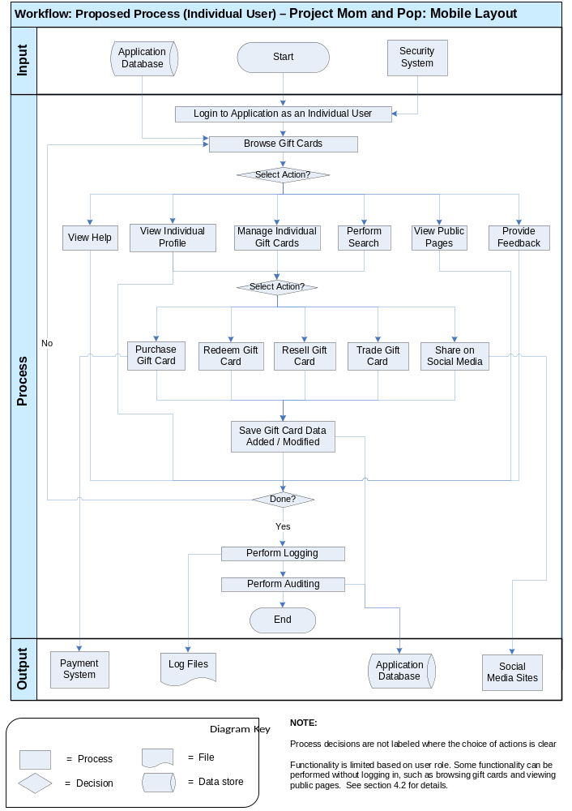

The workflow diagram above shows the high level workflow for Individual users in the new mobile layout.

- The user logs into the mobile layout as an Individual user (authenticated by security system). See login / registration workflow above for details.
  - Possible Opportunity: There is the opportunity to leverage an existing security service for authentication and user management (the client does not have an existing security system).
  - Possible Problem: If there is a problem with Internet access or a connection to one of the external system dependencies (see 3.2.2) the user may not be able to access the application or have the application function correctly.
- The Individual user will be able to browse gift cards available on the platform for sale or trade.
- The Individual user will be able to select different actions to perform:
  - View Help
  - View Public pages including forums
  - View Individual Profile
  - Manage Individual Gift Cards
    - View gift card the user owns
    - Redeem gift cards
      - The individual’s private profile page will display all owned gift cards. At the top of the page, there will be a “Redeem Now” button.
      - Upon pressing the “Redeem Now” button, the camera on the user’s mobile device should be opened.
      - The individual then scans the QR code printed by the Business administrator/Business employee, and the QR code is decoded and the total bill is then decremented from the individual's gift cards.
        - Possible Opportunity: There is the opportunity to leverage an existing QR scanning solution.
      - The application should then prompt the individual if additional payment is required to complete the transaction.
      - If no additional payment is required, the individual should be brought to the current Business’s entry in the wallet with the new balance prominently placed. The most recent transaction should be listed in the detail, and listed near the new balance.
    - Purchase a gift card
      - Once logged in and accessing the gift card search or purchase functionality in the mobile layout, the individual may browse all open gift cards from the main application home page and click on a specific gift card posting, OR the individual may search for a specific gift card posting from the search box on any page, OR the individual may follow a link from an external source (social network, email, etc.) to directly link to a gift card posting.
      - From the gift card posting profile, the individual will click on the “Buy gift cards now” button.
      - A form will pop up that enables the individual to agree to the specific terms of the gift card as well as the denominations and the quantities of gift cards.
      - Once all the necessary data points are entered, the individual will be brought to a confirmation page that will bring the individual to different payment options (e.g. Amazon, PayPal, etc.)
      - Once payment is confirmed, the gift cards will be issued and the transaction will be posted in the individual’s profile that may be accessed through the Web application or the gift card wallet area of the mobile layout.
      - The individual will be brought to their private profile page so they can view the recently purchased gift cards.
    - Resell the gift card
      - Once logged in and accessing the gift card search or purchase functionality in the mobile layout, the individual will be able select “View gift cards”. The private profile will itemize owned gift cards by Business and each row should display a “resell” button.
      - Upon pressing the resell button the individual should be presented with a form to determine the desired resale price and easily select all the gift cards for that Business to be included for resale.
      - Each owned gift card will be listed and next to each gift card should display a “resell” button.
      - Upon pressing the resell button the individual should be presented with a form to determine the desired resale price.
      - The form should communicate whether or not the gift card has exceeded the resale date/time. Although the individual can still resell the gift card, it is important for them to know if they will be competing with a Business’s current gift card posting.
      - If the Business has a gift card currently posted, the individual should be informed of the discount offered.
      - If another individual has gift cards for the same Business currently posted for resale, the individual should be informed of the discount offered.
      - The form will also display “share” buttons to offer gift cards for resale to friends of the individual on popular social networks (i.e. Facebook, Twitter, etc.)
      - Once the price has been confirmed, the user should be notified that their gift card has been offered for resale to all other platform members and the other broadcasted networks that they chose.
      - The gift card should then appear as “For Resale” in the open gift card postings.
    - Trade the gift card
      - Once logged in and accessing the gift card search or purchase functionality in the mobile layout, the individual will be able select “View gift cards”. The private profile will itemize owned gift cards by Business and each row should display a “trade” button next to the “resell” button.
      - Upon pressing the trade button the individual should be presented with a prompt to easily select the number of gift cards for that Business to be included for trade.
      - Each owned gift card will be listed and next to each gift card should display a “trade” button next to the “resell” button.
      - Upon pressing the trade button the user should be notified that their gift card has been offered for trade to all other platform individuals, and the gift card should then appear as “For Trade” in the open gift card postings.
      - When a second individual comes across the posting for the “For Trade Gift Card” and clicks on it, the second individual should be presented with a form on which the second individual can choose which owned gift card they would like to trade with the first individual.
      - There may be rules around the value/denominations of gift card trading. If there are rules, the second individual should be informed if the trade meets those rules.
      - The original individual will then be notified that their gift card has been chosen for trade.
      - Upon viewing the notification, that user should be presented with a form on which they can confirm, negotiate or decline the trade.
      - If the trade is declined, the second individual will be notified and the transaction will cease. If the trade is negotiated, the two individuals may continue going back and forth until a trade is confirmed or declined. If the trade is confirmed, both users will be notified and the transaction will be approved.
      - When the transaction is approved, the designated gift cards will be swapped into the other Individual’s profile.
    - Share a gift card sale or trade offer on popular social media sites.
      - Possible Opportunity: There is the opportunity to leverage an existing social media sharing system (many open source solutions exist). Alternatively, the system could leverage the APIs of the largest social media sites (such as Facebook and Twitter).
      - Possible Bottleneck: The speed and performance of the social media platform used for sharing is a possible bottleneck for the application.
  - Search for gift cards
  - Provide Feedback
- The application will save updates to the system for any of these actions.
- The user can log out of the system when they are done.
- Logging will be performed.
- Auditing will be performed.
- The user will be logged out from the system in case of idleness during configurable period.

Business Employee Workflow (Mobile layout)

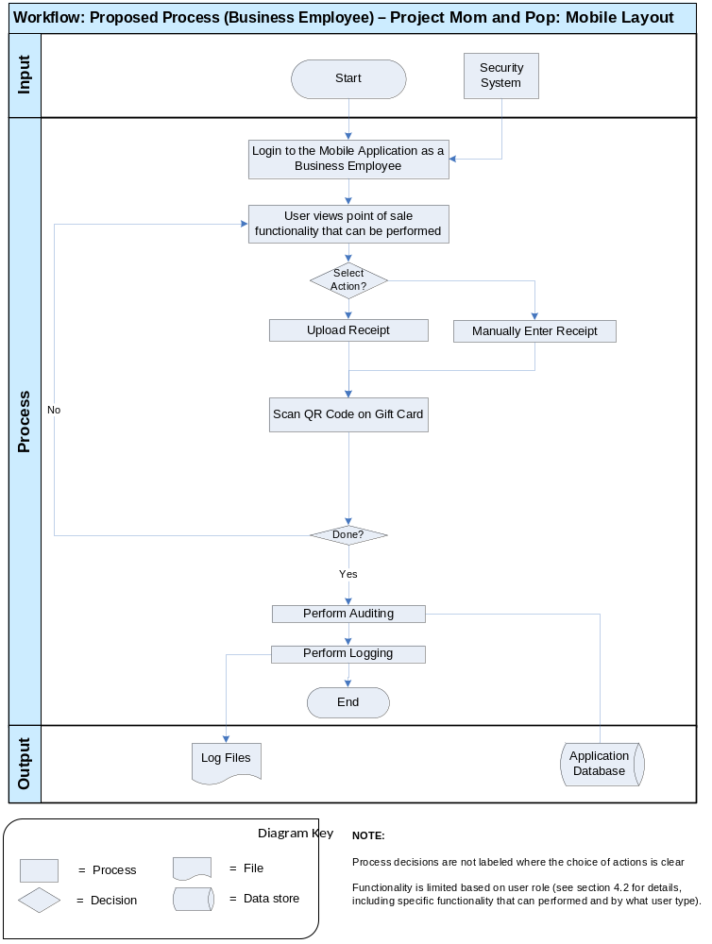

The workflow diagram above shows the high level workflow for Business Employee users in the new mobile layout. The focus of this workflow is point of sale.

- The user logs into the web app on their mobile device as a Business Employee user (authenticated by security system by his/her secret code provided by Business Admin).
  - Possible Problem: If there is a problem with Internet access or a connection to one of the external system dependencies (see 3.2.2) the user may not be able to access the application or have the application function correctly.
- The user will be able to select the point of sale functionality they wish to perform.
  - Scan QR Code on the gift card
  - Upload Receipt
  - Manually Enter Receipt
  - NOTE: Upon initial access to the gift card point of sale functionality in the mobile layout, the employee should be brought to a step-by-step tutorial for how to complete the point of sale.
- The system will generate a QR code that the customer (gift card owner) can scan to redeem their gift card.
  - Possible Opportunity: There is the opportunity to leverage an existing QR scanning solution for this functionality.
- The user can log out of the system when they are done.
- Logging will be performed.
- Auditing will be performed.
- The user will be logged out from the system. They will not be able to access certain the application functionality until they open it again and go through the login process.

NOTE: The Client user also has access to all of the Business Administrator user workflow. In addition, the Client can set permissions for which employees have the role of Business Administrator.

Business Administrator Workflow (Mobile layout)

The Business Administrator workflow for the mobile layout is very similar to the Business Employee Workflow above. The Business Administrator has access to all Business Employee functionality. The only big difference is the Business Administrator also has access to view reporting and add employee accounts (see section 4.2 for details).

Use Case Diagrams
Use case diagrams are helpful illustrations of how the application’s users interact with the system. Use case “bubbles” correlate to distinct task domains and are useful in determining user roles, module boundaries, shared tasks, etc. The use case diagram is intentionally high level, and exclude activity details such as for example “submit shopping cart.” The diagram below should be used to verify that the required functionality of the application is covered.

The use case diagrams follow the coloring schema below for use cases:

Color | Description
 | Regular use case (concrete)
 | Aggregate use case
 | External use case (not in scope)

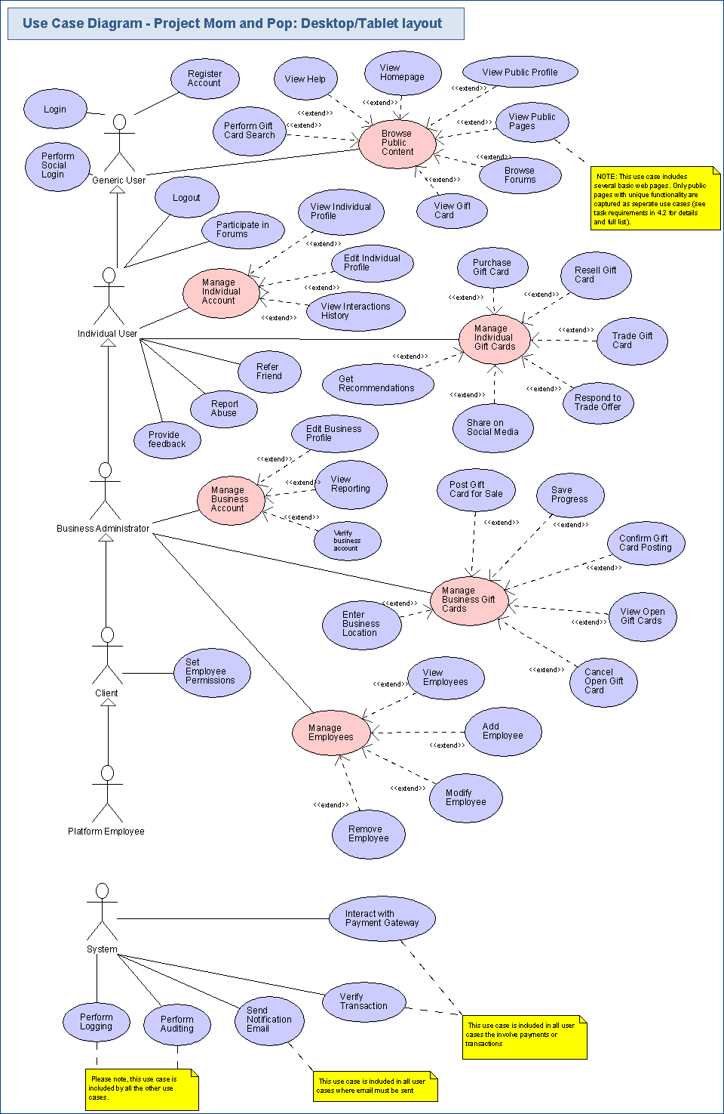
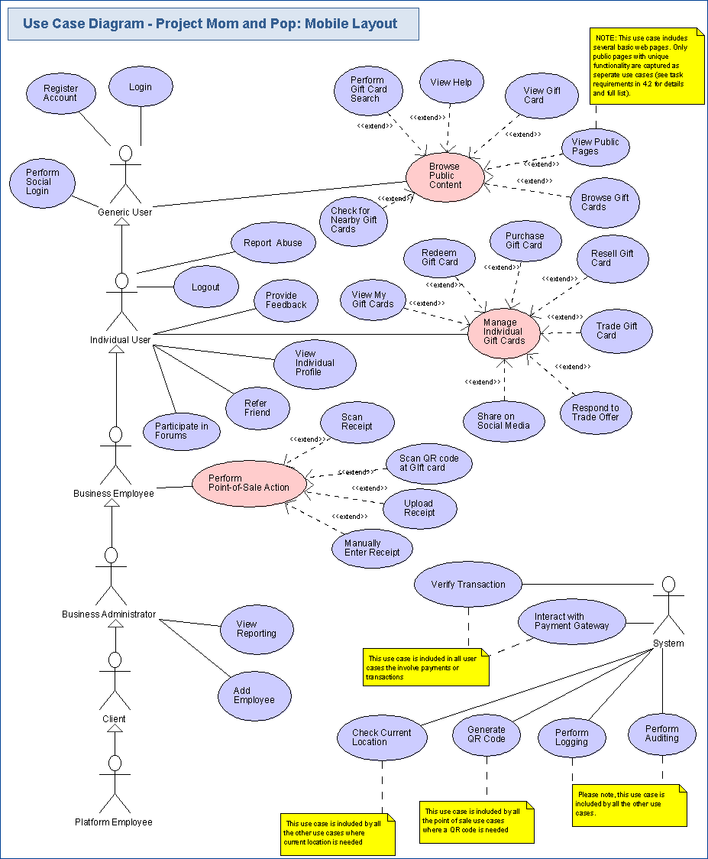

Business Requirements

This section identifies, enumerates and explores the business requirements that must be met by the application. Business requirements include capturing the basic inputs and outputs, the types of users and the tasks the system should accomplish.

Inputs/Outputs
This section identifies and describes the inputs to and outputs from the new application. Human inputs are not described in this section.

Inputs

Data from Payment Gateways
The application will receive data from the payment system (such as confirmations of transactions).

Requests from Social Media Sites
The application will communicate with social media sites for user registration via their existing accounts. Social media users who click a link that was shared with them will also include data the system can use to properly redirect the user.

Scanned QR Codes
The application will scan in QR codes with the mobile device during the redemption process (point of sale).

Uploaded Receipts
The application will allow employees to upload receipts (such as image files) during the redemption process (point of sale).

Location Information
Location information will be input to the application from GPS or the location service.

Coordinates
Coordinates will be needed as input so that user can prove he/she is at the location with the POS mobile layout.

Registration Data
The user will enter registration data to create a new account.

Credentials
The user will enter their credentials to login to the system.

Gift Card Search Data
The user will enter search terms for the gift card search they wish to perform.

Report Input Data
The user will enter input data for the report they wish to generate.

Outputs

Data to Payment System
The application will send data to the payment system (such as transactions to be processed).

Social Media Share Requests
The application will communicate with social media sites to send content users have requested to share. Referral requests to friends will also be sent out via social media.

Logging Data
The application will save logging data of all errors, exceptions, and warnings to log records.

Auditing Data
The application will save all changes made to the database as auditing records.

Email
The application will generate emails to send out (such as notifications and friend referrals).

Generated QR Codes
The mobile layout will generate a QR code that contains characters that make a key for the gift card and data of Individual who owns this card.

Reports
The application will generate reports for the users to view.

Gift Card Data
The application will display gift card data such as search results and gift card details.

Error Messages
The application will display error messages.

Task Requirements
Task Requirements correlate to the use cases, above. There should be at least one task for each use case bubble. Each use case should be briefly described. If there are specific requirements related to the use case, they should also be listed. This section captures the application’s functional requirements. Detailed requirements will be defined during the Requirements Specification contests.

Web Application Functionality

The following task requirements are in scope for the web application.

Generic User Functionality (Desktop web layout)
The generic user refers to any user of the application, including users that are not currently logged in. It is used to represent requirements and functionality available to anyone using the application.

Login
- User’s credentials are verified to ensure they are authorized to use functionality of the application.
  - Users should have the option to sign in with a platform account (see “Register Account” use case below for creating a platform account).
- Users should be prompted to log in or register when they perform actions such as:
  - Trying to purchase, resell or trade a gift card
  - Clicking the sign in button
  - Looking up account information
  - Accessing reports
  - Posting/commenting to forums
- The user should also be able to sign in from any page on the site.
- Credentials will be authenticated via the security system.
- A user who successfully logs in will have additional functionality available to them in the application based on their user role.
- The content displayed on the homepage will also be different based on the user’s role in the system.
- If the user receives a prompt to log in or register based on the above actions, as soon as the user logs in, the user should be redirected to the appropriate page.

Perform Social Login
- Users will have the option to sign in with existing social media accounts (Facebook, LinkedIn, Twitter, etc.).
- The application will communicate with the selected social media platform to verify the user’s existing account.

Register Account
- Users will have the ability to register for an account on the platform.
- Upon visiting the platform, the user will be brought to the sign-in page where they will be prompted to either sign in or browse the platform. If the user chooses to browse they will be brought to the homepage displaying all open gift cards for sale, resale, or trade. The sign-in page should also display buttons at the top of the page allowing the user to navigate directly to any public page on the platform.
- The user may browse every public page of the site but will be prompted to sign in upon attempting to make any buying, selling or trading action, and an attempt to view account details. The user is brought to the sign in page to proceed.
- If the user chooses to register, they will be prompted:
  - To register as an individual if the user is attempting to purchase or trade a gift card.
  - To register as a client if the user is attempting to post a gift card.
  - To register as an individual if they follow a link sent by an existing platform individual through platform or from any non-platform source (social network, email, etc.)
- Client Registration:
  - The client will be prompted to sign in with an existing account (Facebook, LinkedIn, Twitter, etc.) OR enter an email address and password. They will have the option to create a business profile for the Business which will include details like the name of the business and the location:
    - Business Name
    - Business Location / Address
    - Website URL
    - Business Type
    - Business Description
    - Contact Details
    - Hours Open
  - The profile will also include a description of the business to be seen on any of the posted gift cards.
  - The client should also be able to post an optional profile picture and/or logo.
  - Upon completion of the form, the client will be brought back to the page that initiated the call to registration.
  - NOTE: Clients will automatically have access to an individual account (Individual user functionality) when they register their client account.
  - When the user choses to register as a business owner, they will be prompted to either request verification or continue browsing the site. Upon requesting verification, the user will be prompted to pay the monthly subscription fee. The verification request will not be processed until the subscription fee is paid. Until a business is verified, the status will say "Not a verified business". Once the business has been verified, the status will change to "Verified business”.

- Individual Registration:
  - The individual will be prompted to sign in with an existing account (Facebook, LinkedIn, Twitter, etc.) OR enter an email address, name and password.
  - There will be an option to upload a profile picture.
  - The individual will then be brought back to the page that originated the call to register.
- Once the registration process is complete the user account will be saved into the system so the user can login.

Perform Gift Card Search
- Users will have the ability search the platform for gift cards
- The user will enter search criteria, such as:
  - Business name
  - Business type
  - Gift card amount
  - Sale or trade?
  - Business Location
- The search results will be displayed.
- The user will be able to view or perform actions (e.g. buy or sell/trade if they already own it) on the gift cards displayed in the search results.

View Homepage
- A user can view the homepage of the application, which includes the ability to browse all gift cards available on the platform.
  - Gift Card Details, such as:
    - Business name
    - Business type
    - Gift card amount
    - Overall goal
    - Progress towards goal
    - Sale or trade?
    - Business Location
    - Hours open
- The homepage of the platform will serve as the gift card “market” of the site and should display all open gift cards for sale, resale or trade. The list of Businesses with open gift cards on the homepage should be organized by location, goal amount offered, etc.
- The homepage should also display recommendations to users based on account activity and the specific criteria the user has been interested in.
- The content displayed on the homepage will also be different based on the user’s role in the system.
  - Individual Users: The homepage will display their private profile including gift cards owned or up for resale or trade, amount sold, traded or redeemed with the information broken out by Business. An individual should also be able to view their profile from the homepage.

View Gift Card
- A user can view details about a specific gift card available on the platform.
- If the user has been sent a shared link to a gift card the application will take the user directly to the view gift card profile page with details displayed.
- Questions and comments regarding the specific gift card can be posted and will be displayed on the gift card profile page.

Browse Forums
- A user can select to browse the discussion forums where users can ask questions about the platform.
- Until user logs in they can only view discussion but not participate in it.
- Forums will be viewable by the public.
- The discussion forum functionality, such as posting, can be handled by a third party solution (open item).

View Public Profile
- A user can select to view any public profile of a business / individual.
- Details that the business / individual has agreed to share with the public will be displayed.
- This includes gift cards the business / individual has available for sale or trade.

View Public Pages
- A user can select to view any public page without being signed into any account. This includes:
  - Homepage (see “View Homepage” use case)
    - NOTE: The content / functionality available on the homepage will be different based on user role.
  - For the Business
  - For the Individual
  - Business Network
  - How it works
  - Credits Page - all those who have contributed to the platform
  - Blog
  - Forums
  - Frequently Asked Questions- should be organized according to percentage of members who asked the question (see “View Help” use case)
  - About us
  - Legal
  - Contact
  - Sign in (see “Login” use case)

View Help
- The application will have a "how-to" page as well as a Frequently Asked Questions (FAQ) page.
- The FAQ page should have questions organized by the percentage of users that asked the question, starting with the most asked questions.
  - This can be calculated by having a simple plus ‘+’ or ‘-‘ button, or a “Did this help? Yes/No” button next to each FAQ. Users can click this button to indicate if a FAQ question was helpful and the organization will be based on this value.
- The "how-to" page will include helpful information on how to use the application.
- The help content will be related to the current page.

Individual User Functionality (Desktop web layout)
The Individual user is a person who buys and resells/trades a gift card.

Logout
- When the user is done using the system and closes the application they will be logged out from the system.
- The application will also have session timeout functionality to automatically log user out after a specific amount of time inactive.
- After log out, user will only be able to access public areas of the web application until they go back through the log in process.

Participate in Forums
- A user can select to participate in the discussion forums where they can ask questions about the platform.
- This includes the ability to write/delete/reply/attach files to forum posts.
- The discussion forum functionality, such as posting, can be handled by a third party solution (open item).

Provide Feedback
- The desktop layout will allow the user to provide feedback from any page.
- The feedback they submit should include details.

Report Abuse
- The desktop layout will allow the user to report abuse for any user generated content.
- This is important since gift cards will be user generated content. As such, they need to be either pre-moderated or be able to be reported as abuse.

View Individual Profile
- An Individual user will be able to view their private profile including their gift cards owned or up for resale or trade.
  - The private profile will itemize owned gift cards by Business and each row should display a “trade” button, a “resell” button, and a “share” button.
- Their private profile will also include the amount sold, traded or redeemed with the information broken out by Business.
- Each Individual user will be assigned a reliability rating based on payment history, account activity, etc. NOTE: This reliability rating feature has been moved out of scope until a future version of the platform (see 1.5).
- Reports and account info should be displayed on the profile page.
- A history of interactions with other users should appear on Individual profile pages.
- An individual’s platform profile should show all Businesses currently supported by the individual and any gift cards currently available for resale or trade. This information should be private.

Edit Individual Profile
- An Individual user will be able to edit their individual profile and payment information.

View Interactions History
- An Individual user will be able to view their interactions history.
- This includes businesses and individuals the user has bought, sold, or traded gift cards.

Purchase Gift Card
- An Individual user will be able to purchase gift cards available on the platform.
- The individual may browse all open gift cards and click on a specific gift card posting, OR the individual may search for a specific gift card posting from the search box on any page, OR the individual may follow a link from an external source (social network, email, etc.) to directly link to a gift card posting.
- From the gift card posting profile, the individual will click on the “Buy gift cards now” button.
- A form will pop up that enables the individual to agree to the specific terms of the gift card as well as the denominations and the quantities of gift cards.
- Once all the necessary data points are entered, the individual will be brought to a confirmation page that will bring the individual to different payment options (e.g. Amazon, PayPal, etc.). NOTE: Payments will be handled via the external payment system.
- Once payment is confirmed, the gift cards will be issued and the transaction will be posted in the individual’s profile that may be accessed through the Web application or the gift card wallet mobile layout.
- The individual will be brought to their private profile page so they can view the recently purchased gift cards.

Resell Gift Card
- An Individual user will be able to resell gift cards they own.
- Upon logging in to the Web application, the individual will be able to view their private profile. The private profile will itemize owned gift cards by Business and each row should display a “resell” button.
- Upon pressing the resell button the individual should be presented with a form to determine the desired resale price and easily select all the gift cards for that Business to be included for resale.
- The form should communicate whether or not the gift card has exceeded the resale date/time. Although the individual can still resell the gift card, it is important for them to know if they will be competing with a Business’s current gift card posting.
- If the Business has a gift card currently posted, the individual should be informed of the discount offered.
- If another individual has gift cards for the same Business currently posted for resale, the individual should be informed of the discount offered.
- The form will also display “share” buttons to offer gift cards for resale to friends of the individual on popular social networks (i.e. Facebook, Twitter, etc.)
- Once the price has been confirmed, the user should be notified that their gift card has been offered for resale to all other platform members and the other broadcasted networks that they chose.
- The gift card should then appear as “For Resale” in the open gift card postings on the platform.

Trade Gift Card
- An Individual user will be able to trade gift cards they own.
- Upon logging in to the Web application, the individual will be able to view their private profile. The private profile will itemize owned gift cards by Business and each row should display a “trade” button next to the “resell” button.
- Upon pressing the trade button the individual should be presented with a prompt to easily select the number of gift cards for that Business to be included for trade.
- Upon pressing the trade button the user should be notified that their gift card has been offered for trade to all other platform individuals, and the gift card should then appear as “For Trade” in the open gift card postings.
- When a second individual comes across the posting for the “For Trade gift card” and clicks on it, the second individual should be presented with a form on which the second individual can choose which owned gift card they would like to trade with the first individual.
- There may be rules around the value/denominations of gift card trading. If there are rules, the second individual should be informed if the trade meets those rules.
- The original individual will then be notified that their gift card has been chosen for trade.

Respond to Trade Offer
- An Individual user will be able to respond to gift card trade requests they receive.
- Upon viewing the notification of a trade request, that user should be presented with a form on which they can confirm, negotiate or decline the trade.
- If the trade is declined, the second individual will be notified and the transaction will cease. If the trade is negotiated, the two individuals may continue going back and forth until a trade is confirmed or declined. If the trade is confirmed, the both users will be notified (via email on in-app notifications) and the transaction will be approved.
- When the transaction is approved, the designated gift cards will be swapped into the other Individual’s profile.

Get Recommendations
- Users can get recommendations on gift cards.
- The application will analyze the user’s history and provide a list of recommended gift cards that are similar to businesses they have bought or sold gift cards from in the past.
- The recommended gift cards will be displayed.

Share on Social Media
- As they are browsing gift cards on the platform, the user will be able to offer gift cards they see to their friends and family using existing social media sites.
- They can click a “share” button to offer gift cards for resale to friends of the individual on popular social networks (i.e. Facebook, Twitter, etc.)
- The application can make use of existing social network APIs to share gift cards they have for sale / trade.
- The system will save the link to the social network in order to reuse the auth token for the next time sharing with this social network.
- Only basic details will be shared like business name and type of business, along with a link their friends can click to get more details on the gift card by viewing it directly on the platform. Sharing also allows a user to include a personalized message.

Refer Friend
- An Individual user will be able to refer their friends to use the platform.
- The user will select how to send the referral to their friend (such as email or social media).
- The referral message will be sent including a link to take the friend to the application.

Business Administrator Functionality (Desktop web layout)
A Business Administrator is a person associated with the business (this can be the Client himself). Business Administrators have the ability to add and manage employee users. Also, a Business Administrator may be associated with more than one business.

Edit Business Profile
- A Business Administrator user will be able to edit the business profile of the business they are associated to (including payment information).
  - Business Name
  - Business Address
  - Business Coordinates (via location service to prove user is truly at this location).
  - Website URL
  - Business Type
  - Business Description
  - Contact Details
  - Hours Open
- This includes the ability to set what information will be available publicly for other users of the platform to view.
- Reports and account info should be displayed on the profile page.

Verify Business Account
- A Business Administrator user will be able to verify the business account they are associated to (including payment information).
- Upon requesting verification, the user will be prompted to pay the monthly subscription fee. The verification request will not be processed until the subscription fee is paid.
- Until a business is verified, the status will say "Not a verified business". Once the business has been verified, the status will change to "Verified business”.

View Reporting
- A Business Administrator user will be able to view reporting for gift cards related to their business.
- Reporting will include details such as how many gift cards the business has sold, how many have been redeemed, how many are outstanding, and how far to the goal.

Post Gift Card for Sale
- A Business Administrator user will be able to post gift cards for sale on the platform.
- If a gift card posting has previously been saved the user may choose to load the saved progress.
- Upon clicking the “Post a gift card” feature at the top of the Webpage that displays all open gift cards, the client or the Business Administrator will be prompted to fill out a gift card Posting Application form.
  - The form should be saved as a work in progress.
- The form will require the purpose for the posting, start date, end date, max threshold, currency and locations for redemption.
  - The Business Administrator will set the transaction amount.
  - The Business Administrator will set the discount amount.
    - If the discount is not within suggested boundaries the founder should be notified that they are outside the suggested discount boundaries and prompted to either cancel the transaction or let it go through anyway.
- The application to post a gift card will have additional requirements to be determined.
  - Predetermined posting requirements may include certain industries, good standing in payments, etc. The client hopes to be able to add and change posting requirements within the platform as needed.
- Upon completion of the application, the client should be prompted to verify their account information.
- Once completion of the form is confirmed and account information is verified, the Business will be notified via email.
- Once the Business submits the confirmation link, the account will be charged and the gift card post will be published on the platform.
- A gift card may not be posted for sale until the following requirements are satisfied:
  - The Business has no active gift cards
  - The amount of the transaction is set
  - The Business has been verified
  - The Business has paid the monthly subscription fee
  - The account for the Business to get paid through platform has been verified
  - Any additional predetermined posting requirements are met
- Once the transaction requirements above are satisfied, the gift card can be officially posted and published on the platform.

Save Progress
- A Business Administrator user can save the progress of their gift card posting application.
- The current progress and information that has been entered will be saved so the process can be continued later.

Enter Business Location
- A Business Administrator user will be able to enter their business location so it can be used by the application for verification purposes.

Confirm Gift Card Posting
- The Business Administrator will need to confirm the gift card sale before the posting goes live for sale on the platform.
- All the details about the gift card will be displayed so the user can see everything that has been entered.
  - Gift Card Details, such as:
    - Business name
    - Business type
    - Gift card amount
    - Sale or trade?
    - Business Location
    - Max quantity available
    - Sale end date
- The Business Administrator can confirm the gift card posting and it will go live on the platform.

View Open Gift Cards
- A Business Administrator user will be able to view open gift cards related to their business.
- All open gift cards for the business will be displayed.

Cancel Open Gift Card
- A business administrator should be able to cancel a gift card posting at any time; however they must honor any outstanding gift cards.
  - This means the gift cards already purchased will stay active in the system (users can still redeem them via POS) but no new ones will be available to buy on the platform.
- The application will ask the business administrator to confirm they want to cancel the open gift card they selected.
- The gift card will be cancelled and will no longer be displayed on the platform for sale.

View Employees
- A Business Administrator user can view Business Employee users associated with their business.
- A list of all employee accounts that have been created for their business will be displayed.
- The Business Administrator will be able to perform actions on these employees such as modifying or removing them.

Add Employee
- A Business Administrator user can add Business Employee user accounts that will be associated with their business.
- From the Business profile page, the user should be able to click an “add new employee account” feature
- The user should be prompted to enter an employee name and a secret alphanumeric code. Business employee will use this code to enter the system instead of email + password credentials.
- An employee will be instructed how to proceed by Business Administrator outside of platform.

Modify Employee
- A Business Administrator user can modify Business Employee users that have been created for their business.
- The Business Administrator will select what information to modify and make any necessary changes including the secret code.
- The updated Business Employee details will be saved to the system.

Remove Employee
- A Business Administrator user can remove Business Employee users that have been created for their business.
- The Business Administrator will select the Business Employee account they wish to remove and confirm they wish to remove the selected account.
- The selected Business Employee account will be removed from the system and won’t be able to sign in with the secret code anymore.

Client Functionality (Desktop web layout)
A Client is the business owner. They have the ability to perform all the same tasks that Business Administrators can (such as posting gift cards and adding and managing employees), but with some additional functionality. This includes the ability to assign the Business Administrator role to specific employees.

Set Employee Permissions
- A Client user will be able to set and edit the permissions of employee users associated with their business.
- This includes the ability to assign employees the permission to be a Business Administrator, or to withdraw the Business Administrator role from employees.

Platform Employee Functionality (Desktop web layout)
Platform employees are users which may help a Business or Individual with a transaction on the platform. Platform employees will have access to the entire platform in order to manage content and activity. This includes the ability to add and manage users. Essentially, they act as the application administrator.

- A Platform employee user will have access to the entire platform in order to manage content and activity (including all web application use cases above).
- A Platform employee will have access to the “Set Employee Permissions” use case above, except they can also assign or withdraw permission for the Platform Employee role for other users in the system.

System Functionality (Desktop web layout)
The system is a non-human actor in the application. It represents processes which are initiated by the application (although they may be triggered by user input).

Interact with Payment Gateway
- The system will need to interact with payment gateways for processing payments (the specific payment system is an open item).
- The system will communicate with the payment gateway so it can send and receive payment requests / confirmations.

Verify Transaction
- The system will need to verify and process transactions that occur on the platform.
- This includes verifying location in some cases.
- This use case also includes internal verification and triggering processes such as: “If a gift card post transaction reaches the amount of the transaction (maximum threshold), the offer will be closed and no more gift cards may be purchased for that Business at that time”.

Send Notification Email
- The system will be required to send emails as part of some use cases.
- Emails sent include notifications about gift card state changes (such as posting closed, hits a milestone, etc.).
- The system will generate emails and send them to the users associated to the gift cards.

Perform Logging
- Logging is required by the application to help with support and maintenance.
- The system will log all errors, exceptions, warnings, and debugging information during application execution.
  - For example, while the application is running an unexpected error may occur that prevents the user from performing an action.
  - The error would be stored in the logs, so the client could have their technical team look at the logs to determine the problem and fix it so it doesn’t happen again.
- Date and timestamp of event will be included in logs.
- Logged information will not include any sensitive information such as user credentials.
- Logging information can be stored in flat files on the application server.

Perform Auditing
- Auditing is required by the application in case there is the need to review user actions to settle any type of issue relating to user behavior.
- The system will audit the action performed by the user where any data is added, modified, or deleted.
  - Data and timestamp
  - Username (if available)
  - IP Address of user (if available)
  - Old data value that was modified or deleted (if applicable)
  - New data value that was added or modified (if applicable)
- User credentials cannot be audited.
- Data definitions and how audited data is stored will be defined by the architect.

Mobile layout Functionality

The following task requirements are in scope for the mobile layout.

Generic User Functionality (Mobile layout)
The generic user refers to any user of the application, including users that are not currently logged in. It is used to represent requirements and functionality available to anyone using the application.

Login
- Done in the same manner as in the web layout (4.2.1.1)
- Business employee can also sign in the platform in mobile layout with his/her secret code provided by Business Administrator.

Perform Social Login
- Users will have the option to sign in with existing social media accounts (Facebook, LinkedIn, Twitter, etc.).
- The application will communicate with the selected social media platform to verify the user’s existing account.

Register Account
- Individual users will have the ability to register for an account on the platform via the mobile layout.
- The user will be prompted to sign in or register when a mobile layout is opened.
- If the user is attempting to open the “Gift Card Search and Purchase” or the “Gift Card Wallet” functionality in the mobile layout, the user will be prompted to register as an individual.
  - The user will be prompted to sign in with an existing account (Facebook, LinkedIn, Twitter, etc.) OR enter an email address, name and password.
  - The user will enter details about themselves like name and address (location).
  - There will be an option to upload a profile picture.
  - The user will then be brought back to the main mobile layout home page.
- If the user is attempting to open the “Gift Card Reporting” functionality in the mobile layout:
  - If the user is not already registered as a Client or Business Administrator, the user will be guided through next appropriate steps and redirected to the web application or a different mobile layout.
- If the user is attempting to open the “Gift Card Point of Sale” functionality in the mobile layout:
  - If the user is not already registered as a Client or Business Administrator or Business Employee, the user will be guided through next appropriate steps redirected to the web application or a different mobile layout.
- The Client’s (Business owner) registration procedure is the same is for the desktop/tablet layout (see details above in 4.2.1.3)

View Public Pages
The use case is as in the desktop/tablet layout.

The Individual user is a person who buys and resells/trades a gift card.

Browse Gift Cards
- A user can select to browse available gift cards using the mobile layout.
- The mobile layout will display all open gift cards for sale, resale or trade on the platform.
- For the owned gift cards, an individual can click a button to signal whether gift cards are for resale/trade. When the button is clicked, a form is activated to allow the individual to determine resale/trade price.
- This application will also display “share” buttons to offer gift cards for resale to friends of the individual on popular social networks (i.e. Facebook, Twitter, etc.).

Check for Nearby Gift Cards
- A user can select to browse available gift cards from nearby businesses using the mobile layout.
- The mobile layout will use GPS and location services to determine the user’s current location and will search for gift cards at nearby businesses to display.

View Gift Card
- A user can view details about a specific gift card available on the platform.
- If the user has been sent a shared link to a gift card the application will take the user directly to the view gift card profile page with details displayed.
- Questions and comments regarding the specific gift card can be posted and will be displayed on the gift card profile page.

Perform Gift Card Search
- Users will have the ability search the platform for gift cards to purchase, resell, or trade.
- The user will enter search criteria, such as:
  - Business name
  - Business type
  - Gift card amount
  - Sale or trade?
  - Business Location
- The search results will be displayed.
  - The results will be displayed with the same information described in the “Browse Gift Cards” use case above.
  - This includes buttons to share or offer gift cards for resale or trade to friends of the individual on social networks, as well as buttons for resale/trade if the gift card is owned by the user.

View Help
- The mobile layout should allow a user to access “Help” from any page to learn more with pictures, diagrams and videos.
- The help content, including pictures, diagrams and videos, will be displayed on the mobile layout for the user to view.
- This includes the ability to view the tutorial on POS.
- The help content will be related to the current page.

Individual User Functionality (Mobile layout)

Logout
- Done in the same manner as in the web layout (4.2.2.1).

Participate in Forums
- A user can select to participate in the discussion forums where they can ask questions about the platform.
- This includes the ability to write/delete/reply/attach files to forum posts.
- The discussion forum functionality, such as posting, can be handled by a third party solution (open item).

Provide Feedback
- The mobile layout will allow the user to provide feedback from any page.
- The feedback they submit should include details.

Report Abuse
- The mobile layout will allow the user to report abuse for any user generated content.
- This is important since gift cards will be user generated content. As such, they need to be either pre-moderated or be able to be reported as abuse.

View Individual Profile
- An Individual user will be able to view their private profile including their gift cards owned or up for resale or trade.
- The private profile page will include a summary of the currently owned gift cards broken out by status (flag for resale, trade or use).
- If the application has permission to use the individual’s location, the list can be sorted by distance, with their current location at the top.
- The top of the profile page should have a button for “Redeem Now”.

View My Gift Cards
- An Individual user will be able to view their gift cards they own.
- The private profile page will include a summary of the currently owned gift cards broken out by status (flag for resale, trade or use).
- The individual will have the option to view gift cards in other ways (e.g. by industry).
- The individual can click on any of the subcategories to drill down to a Business specific level of detail.

Purchase Gift Card
- An Individual user will be able to purchase gift cards available on the platform via the mobile layout.
- Once logged in and accessing the gift card search or purchase functionality in the mobile layout, the individual may browse all open gift cards from the main application home page and click on a specific gift card posting, OR the individual may search for a specific gift card posting from the search box on any page, OR the individual may follow a link from an external source (social network, email, etc.) to directly link to a gift card posting.
- From the gift card posting profile, the individual will click on the “Buy gift cards now” button.
- A form will pop up that enables the individual to agree to the specific terms of the gift card as well as the denominations and the quantities of gift cards.
- Once all the necessary data points are entered, the individual will be brought to a confirmation page that will bring the individual to different payment options (e.g. Amazon, PayPal, etc.)
- Once payment is confirmed, the gift cards will be issued and the transaction will be posted in the individual’s profile that may be accessed through the Web application or the gift card wallet area of the mobile layout.
- The individual will be brought to their private profile page so they can view the recently purchased gift cards.

Redeem Gift Card
- An Individual user will be able to redeem gift cards they own by clicking the “Redeem Now” button.
- Clicking the “Redeem Now” button opens the camera on the individual’s mobile device.
- The Individual then uses his/her mobile device and generates the QR code for gift card (it might be pre-generated and stored by the system).
- The QR code is scanned and decoded by Business employee and the total bill is then decremented from the individual's gift cards that relate to that business/location that are marked for use.
- The mobile layout prompts the individual if additional payment is required to complete the transaction. If not, the individual is prompted and brought to the current Business’s entry in the wallet with the current balance and the most recent transaction listed in the detail.

Resell Gift Card
- An Individual user will be able to resell gift cards they own.
- Once logged in and accessing the gift card search or purchase functionality in the mobile layout, the individual will be able select “View gift cards”. The private profile will itemize owned gift cards by Business and each row should display a “resell” button.
- Upon pressing the resell button the individual should be presented with a form to determine the desired resale price and easily select all the gift cards for that Business to be included for resale.
- Each owned gift card will be listed and next to each gift card should display a “resell” button.
- Upon pressing the resell button the individual should be presented with a form to determine the desired resale price.
- The form should communicate whether or not the gift card has exceeded the resale date/time. Although the individual can still resell the gift card, it is important for them to know if they will be competing with a Business’s current gift card posting.
- If the Business has a gift card currently posted, the individual should be informed of the discount offered.
- If another individual has gift cards for the same Business currently posted for resale, the individual should be informed of the discount offered.
- The form will also display “share” buttons to offer gift cards for resale to friends of the individual on popular social networks (i.e. Facebook, Twitter, etc.)
- Once the price has been confirmed, the user should be notified that their gift card has been offered for resale to all other platform members and the other broadcasted networks that they chose.
- The gift card should then appear as “For Resale” in the open gift card postings.

Trade Gift Card
- An Individual user will be able to trade gift cards they own.
- Once logged in and accessing the gift card search or purchase functionality in the mobile layout, the individual will be able select “View gift cards”. The private profile will itemize owned gift cards by Business and each row should display a “trade” button next to the “resell” button.
- Upon pressing the trade button the individual should be presented with a prompt to easily select the number of gift cards for that Business to be included for trade.
- Each owned gift card will be listed and next to each gift card should display a “trade” button next to the “resell” button.
- Upon pressing the trade button the user should be notified that their gift card has been offered for trade to all other platform individuals, and the gift card should then appear as “For Trade” in the open gift card postings.
- When a second individual comes across the posting for the “For Trade Gift Card” and clicks on it, the second individual should be presented with a form on which the second individual can choose which owned gift card they would like to trade with the first individual.
- There may be rules around the value/denominations of gift card trading. If there are rules, the second individual should be informed if the trade meets those rules.
- The original individual will then be notified that their gift card has been chosen for trade.

Respond to Trade Offer
- An Individual user will be able to respond to gift card trade requests they receive.
- Upon viewing the notification of a trade request, that user should be presented with a form on which they can confirm, negotiate or decline the trade.
- If the trade is declined, the second individual will be notified and the transaction will cease. If the trade is negotiated, the two individuals may continue going back and forth until a trade is confirmed or declined. If the trade is confirmed, the both users will be notified (via email and in-app notifications) and the transaction will be approved.
- When the transaction is approved, the designated gift cards will be swapped into the other Individual’s profile.

Share on Social Media
- As they are browsing gift cards on the platform, the user will be able to offer gift cards they see to their friends and family using existing social media sites.
- They can click a “share” button to offer gift cards for resale to friends of the individual on popular social networks (i.e. Facebook, Twitter, etc.). NOTE: Exact set of social media sites to include is an open issue (see 1.5).
- The application can make use of existing social network APIs to share gift cards they have for sale / trade.
- The system will save the link to the social network in order to reuse the auth token for the next sharing with this social network.
- Only basic details will be shared like business name and type of business, along with a link their friends can click to get more details on the gift card by viewing it directly on the platform. Sharing also allows a user to include a personalized message.

Refer Friend
- An Individual user will be able to refer their friends to use the platform.
- The user will select how to send the referral to their friend (such as email or social media).
- The referral message will be sent including a link to take the friend to the application.

Business Employee Functionality (Mobile layout)
Business Employees work for a business. They have the ability to perform point-of-sale actions for gift cards being redeemed at their business. Upon initial access to the gift card point of sale functionality in the mobile layout, the employee should be brought to a step-by-step tutorial for how to complete the point of sale.

Scan Receipt (POS)
- A Business Employee user will be able to scan a QR code / receipt by taking a photo using the mobile layout.
- The mobile layout then generates a QR code that contains characters that make a key for gift card and data of Individual who owns it.
- The location where this POS transaction occurs at should be verified within the system.
  - Location will be verified using GPS or the locations services.

Upload Receipt (POS)
- A Business Employee user will be able to upload a receipt (such as an image file) using the mobile layout.
- The mobile layout then generates a QR code that contains characters that make a key for gift card and data of Individual who owns it.
- The location this POS transaction occurs at should be verified within the system.
  - Location will be verified using GPS or the locations services

Manually Enter Receipt (POS)
- A Business Employee user will be able to manually enter a receipt using the mobile layout.
- The mobile layout then generates a QR code that contains characters that make a key for gift card and data of Individual who owns it.
- The location this POS transaction occurs at should be verified within the system.
  - Location will be verified using GPS or the locations services.

Business Administrator Functionality (Mobile layout)
A Business Administrator is a person associated with the business (this can be the Client himself). Business Administrators have the ability to perform the same Business Employee functionality (point of sale) via the mobile layout. In addition, they also have access to other functionality such as reporting or adding employees.

View Reporting
- A Business Administrator user will be able to view reporting for gift cards related to their business.
- The reporting page in the mobile layout will be similar to the reporting page in the web application.
- The mobile reporting page should display progress toward goals, time remaining until expiration, amount resold and amount redeemed.

Add Employee
- A Business Administrator user can add Business Employee user accounts that will be associated with their business.
- From the gift card reporting area of the mobile layout, the Business Administrator should be able to click an “add new employee account” feature.
- The user should be prompted to enter an employee name and a secret alphanumeric code. Business employee will use this code to enter the system instead of email+password credentials.
- An employee will be instructed how to proceed by Business Administrator outside of platform.

Platform Employee Functionality (Mobile layout)
Platform employees are users which may help a Business or Individual with a transaction on the platform. Platform employees will have access to the entire platform in order to manage content and activity. This includes the ability to add and manage users. Essentially, they act as the application administrator.

- A Platform employee user will have access to the entire platform in order to manage content and activity (including all mobile layout use cases above).

System Functionality (Mobile layout)
The system is a non-human actor in the application. It represents processes which are initiated by the application (although they may be triggered by user input).

Generate QR Code
- The mobile layout will have the ability to generate QR codes that can be scanned by the business during the redemption process.
- QR code that contains characters that make a key for gift card and data of Individual who owns it.

Interact with Payment Gateway
- The system will need to interact with payment gateways for processing payments (the specific payment system is an open item).
- The system will communicate with the payment gateway so it can send and receive payment requests / confirmations.

Verify Transaction
- The system will need to verify and process transactions that occur on the platform.
- This includes verifying location in some cases.
- This use case also includes internal verification and triggering processes such as: “If a gift card post transaction reaches the amount of the transaction (maximum threshold), the offer will be closed and no more gift cards may be purchased for that Business at that time”.

Check Current Location
- The mobile layout will check the user’s current location to see if they are at a business location where gift cards are currently available for purchase or trade.
- The mobile layout should prompt the individual if they are at a location where gift cards are currently available for purchase or trade.
- The mobile layout will also use current location to sort gift cards by distance.
- Current location can also be used to verify the location where a transaction takes place.

Perform Logging
- Logging is required by the application to help with support and maintenance.
- The system will log all errors, exceptions, warnings, and debugging information during application execution.
  - For example, while the application is running an unexpected error may occur that prevents the user from performing an action.
  - The error would be stored in the logs, so the client could have their technical team look at the logs to determine the problem and fix it so it doesn’t happen again.
- Date and timestamp of event will be included in logs.
- Logged information will not include any sensitive information such as user credentials.
- Logging information can be stored in flat files on the application server.

Perform Auditing
- Auditing is required by the application in case there is the need to review user actions to settle any type of issue relating to user behavior.
- The system will audit the action performed by the user where any data is added, modified, or deleted.
  - Data and timestamp
  - Username (if available)
  - IP Address of user (if available)
  - Old data value that was modified or deleted (if applicable)
  - New data value that was added or modified (if applicable)
- User credentials cannot be audited.
- Data definitions and how audited data is stored will be defined by the architect.

Security Requirements
This section documents, at a high level, the basic security requirements of the application.

- User Credentials Authenticated
The application will need to verify the credentials of all users to ensure they are authorized to use it. The security system will also be used to manage user accounts / roles in the system.
- Password Strength: Basics password strength requirements should be enforced such as:
  - the use of both upper- and lower-case letters (case sensitivity)
  - inclusion of one or more numerical digits
  - inclusion of special characters, e.g. @, #, $ etc.
  - See http://en.wikipedia.org/wiki/Password_policy for additional suggestions.
- Employee will be provided with a secret code from his/her Business Admin instead of login+password credentials.
- The application will also allow login via existing social media accounts, which could potentially be a serious security problem if not handled correctly.

- User Roles
The application will need to limit the availability of functionality in the application based on the user’s role (see section 4.2 for details).
- Different users will have different permission in the application. The security system must support this.

- Sensitive Information
The application will be working with financial / accounting data that is considered sensitive.

Performance Requirements
Performance Requirements for the application are defined at a high level below. If there are specific requirements for specific features to perform at a quantifiable level, they too are listed below. These requirements will be developed in more detail when the requirements specification is written, in a later phase.

- The application will achieve a 99.5% uptime.
- The application will have 24x7 availability.
- All pages in the application should be loaded in 2 seconds or less after the initial hit.
- The client does not currently have an expected number of unique and concurrent users for the new platform. The client has requested that the platform should be able to handle heavy activity, and that it should be scalable to handle the heavy amount of user activity even as the platform grows.

Data Migration
Data Migration describes the data that needs to be moved from an older or external system to the new system, in order for it to operate at launch. Any data migration requirements are listed below.

No data migration is required for this project.

